Venkateshwar Reddy. N
192312193
Slot: A

Smart Irrigation Communication Model for Crop Monitoring
Concept: Soil-moisture sensors communicate wirelessly with a gateway. The gateway analyzes the data and sends a control command to the irrigation pump.
Matlab Cobe:
clc;
clear;
close all;
% Smart Irrigation Communication Model
% Number of sensor nodes
N = 20;
% Simulation time
T = 100;
% Generate soil moisture values (%)
soil_moisture = 20 + 60*rand(N,T);
% Moisture threshold
threshold = 40;
% Communication parameters
Pt = 10; % Transmit power in dBm
PL0 = 40; % Reference path loss in dB
d0 = 1; % Reference distance
n = 3; % Path loss exponent
noise_power = -90; % Noise power in dBm
% Random sensor positions
x = 100*rand(1,N);
y = 100*rand(1,N);

% Gateway position
gx = 50;
gy = 50;
% Calculate distance from sensors to gateway
distance = sqrt((x-gx).^2 + (y-gy).^2);
% Avoid zero distance
distance(distance < 1) = 1;
% Path loss
path_loss = PL0 + 10*n*log10(distance/d0);
% Received power
Pr = Pt - path_loss;
% SNR
SNR = Pr - noise_power;
% Packet delivery probability
PDR = 1./(1 + exp(-0.3*(SNR-10)));
% Irrigation decision
average_moisture = mean(soil_moisture,1);
pump_status = average_moisture < threshold;
% Display sensor network
figure;
scatter(x,y,80,'filled');
hold on;
plot(gx,gy,'p','MarkerSize',15,'LineWidth',2);
for i = 1:N
plot([x(i) gx],[y(i) gy],'--');
end
xlabel('X Position (m)');
ylabel('Y Position (m)');
title('Smart Irrigation Wireless Sensor Network');
legend('Sensor Nodes','Gateway');
grid on;
% Soil moisture variation
figure;
plot(1:T,average_moisture,'LineWidth',2);
hold on;
yline(threshold,'--','Moisture Threshold');
xlabel('Time');
ylabel('Average Soil Moisture (%)');
title('Crop Soil Moisture Monitoring');
legend('Average Moisture','Threshold');
grid on;
% Pump control
figure;
stairs(1:T,pump_status,'LineWidth',2);
xlabel('Time');
ylabel('Pump Status');
title('Automatic Irrigation Control');
ylim([-0.1 1.1]);
yticks([0 1]);
yticklabels({'OFF','ON'});
grid on;
% Communication performance
figure;
subplot(2,1,1);
bar(1:N,Pr);
xlabel('Sensor Node');
ylabel('Received Power (dBm)');
title('Received Signal Power');
grid on;
subplot(2,1,2);
bar(1:N,PDR);
xlabel('Sensor Node');
ylabel('Packet Delivery Probability');
title('Wireless Communication Reliability');
grid on;
% Display results
fprintf('Average Soil Moisture = %.2f %%\n',mean(average_moisture));
fprintf('Average Received Power = %.2f dBm\n',mean(Pr));
fprintf('Average SNR = %.2f dB\n',mean(SNR));
fprintf('Average Packet Delivery Probability = %.2f %%\n',mean(PDR)*100);
Output:

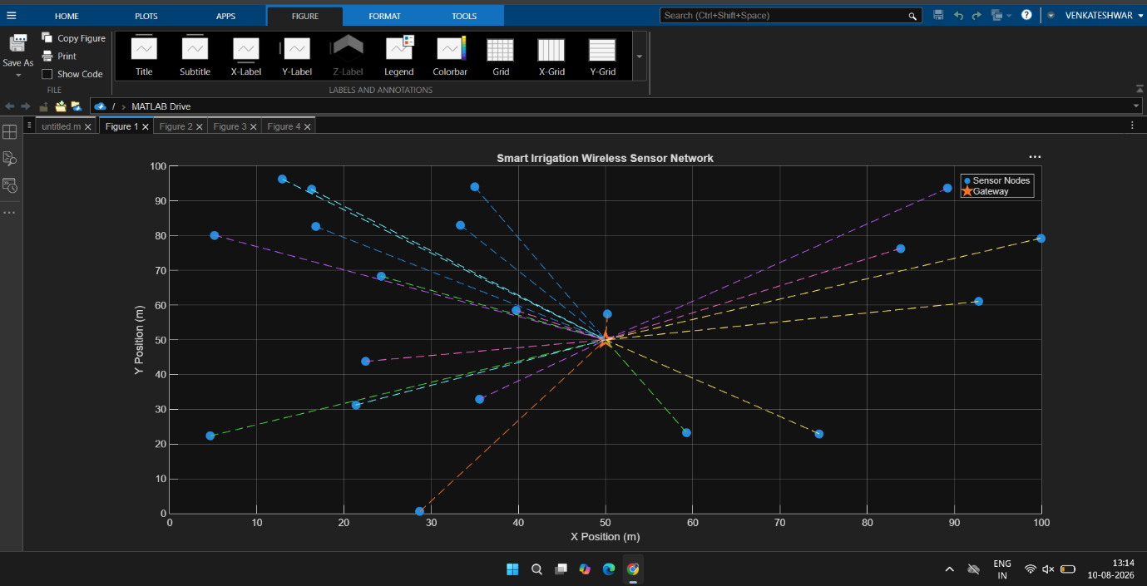
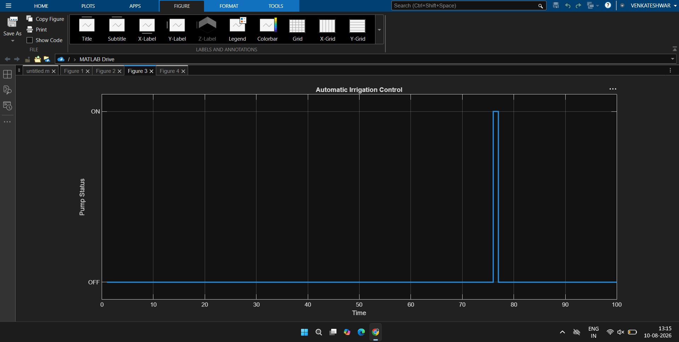
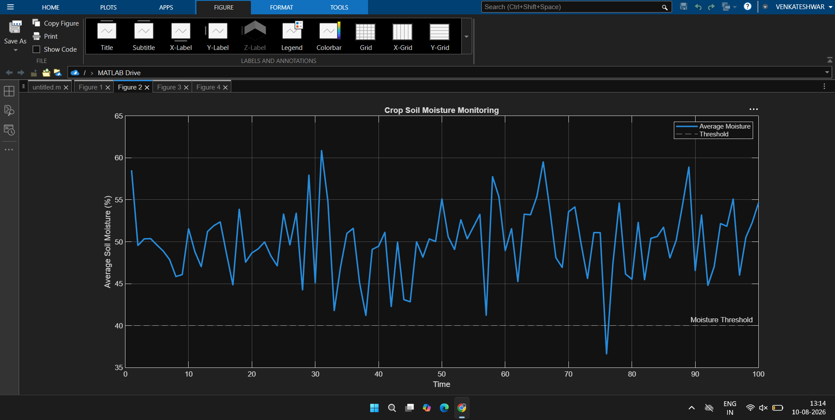

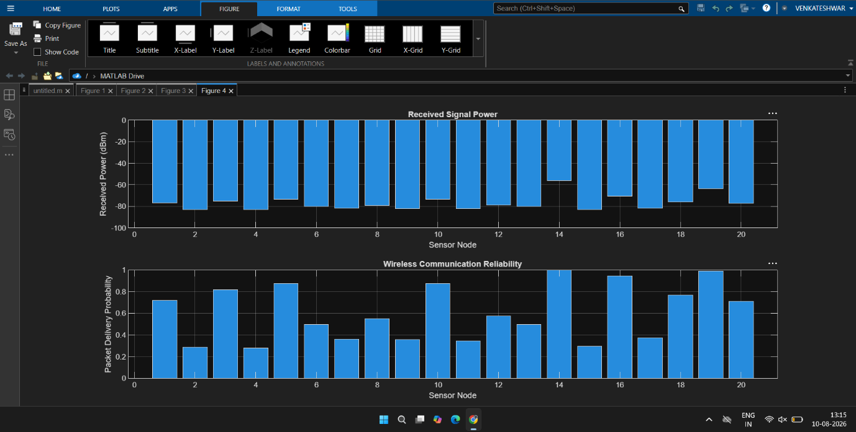
Result: The system successfully monitors soil moisture and automatically activates irrigation when the moisture level falls below the threshold.

Livestock Tracking Communication Architecture Using Wireless Sensors
Concept: Each animal carries a wireless sensor/tag containing location and physiological information. The sensor communicates with a gateway/base station, which forwards the information to a monitoring station.
Matlab Code:
clc;
clear;
close all;
% Livestock Tracking Communication Architecture
% Number of animals
N = 15;
% Simulation time
T = 100;
% Field dimensions
field_x = 500;
field_y = 500;
% Initial animal positions
x = field_x*rand(N,1);
y = field_y*rand(N,1);
% Gateway/base station position
gx = field_x/2;
gy = field_y/2;
% Communication parameters
Pt = 14; % Transmit power in dBm
PL0 = 40; % Path loss at reference distance
d0 = 1;
n = 3; % Path loss exponent
noise_power = -90; % Noise power
% Animal movement
animal_x = zeros(N,T);
animal_y = zeros(N,T);
animal_x(:,1) = x;
animal_y(:,1) = y;
% Generate random movement
for t = 2:T
dx = 10*randn(N,1);
dy = 10*randn(N,1);
animal_x(:,t) = animal_x(:,t-1) + dx;
animal_y(:,t) = animal_y(:,t-1) + dy;
% Keep animals inside field
animal_x(:,t) = max(0,min(field_x,animal_x(:,t)));
animal_y(:,t) = max(0,min(field_y,animal_y(:,t)));
end
% Distance from animals to gateway
distance = sqrt((animal_x-gx).^2 + ...
(animal_y-gy).^2);
distance(distance < 1) = 1;
% Path loss
path_loss = PL0 + 10*n*log10(distance/d0);
% Received power
received_power = Pt - path_loss;
% SNR
SNR = received_power - noise_power;
% Packet delivery ratio
PDR = 1./(1 + exp(-0.3*(SNR-10)));
% Average values
avg_power = mean(received_power,2);
avg_SNR = mean(SNR,2);
avg_PDR = mean(PDR,2);

% Network topology at final time
figure;
scatter(animal_x(:,T),animal_y(:,T),100,'filled');
hold on;
plot(gx,gy,'p','MarkerSize',18,'LineWidth',3);
for i = 1:N
plot([animal_x(i,T) gx], ...
[animal_y(i,T) gy],'--');
text(animal_x(i,T)+5,animal_y(i,T), ...
sprintf('Animal %d',i));
end
xlabel('X Position (m)');
ylabel('Y Position (m)');
title('Livestock Wireless Sensor Tracking Network');
legend('Animal Sensor Nodes','Gateway');
grid on;
axis([0 field_x 0 field_y]);
% Animal movement
figure;
hold on;
for i = 1:N
plot(animal_x(i,:),animal_y(i,:),'LineWidth',1);
end
plot(gx,gy,'p','MarkerSize',18,'LineWidth',3);
xlabel('X Position (m)');
ylabel('Y Position (m)');
title('Livestock Movement Tracking');
grid on;
axis([0 field_x 0 field_y]);
% Received power
figure;
bar(1:N,avg_power);
xlabel('Animal Sensor');
ylabel('Average Received Power (dBm)');
title('Average Received Signal Power');
grid on;
% SNR
figure;
bar(1:N,avg_SNR);
xlabel('Animal Sensor');
ylabel('Average SNR (dB)');
title('Communication Signal-to-Noise Ratio');
grid on;
% Packet delivery ratio
figure;
bar(1:N,avg_PDR*100);
xlabel('Animal Sensor');
ylabel('Packet Delivery Ratio (%)');
title('Wireless Communication Reliability');
ylim([0 100]);
grid on;
% Display results
fprintf('\nLivestock Tracking Communication Results\n');
fprintf('----------------------------------------\n');
fprintf('Average Received Power = %.2f dBm\n', ...
mean(avg_power));
fprintf('Average SNR = %.2f dB\n', ...
mean(avg_SNR));
fprintf('Average Packet Delivery Ratio = %.2f %%\n', ...
mean(avg_PDR)*100);
OutPut:
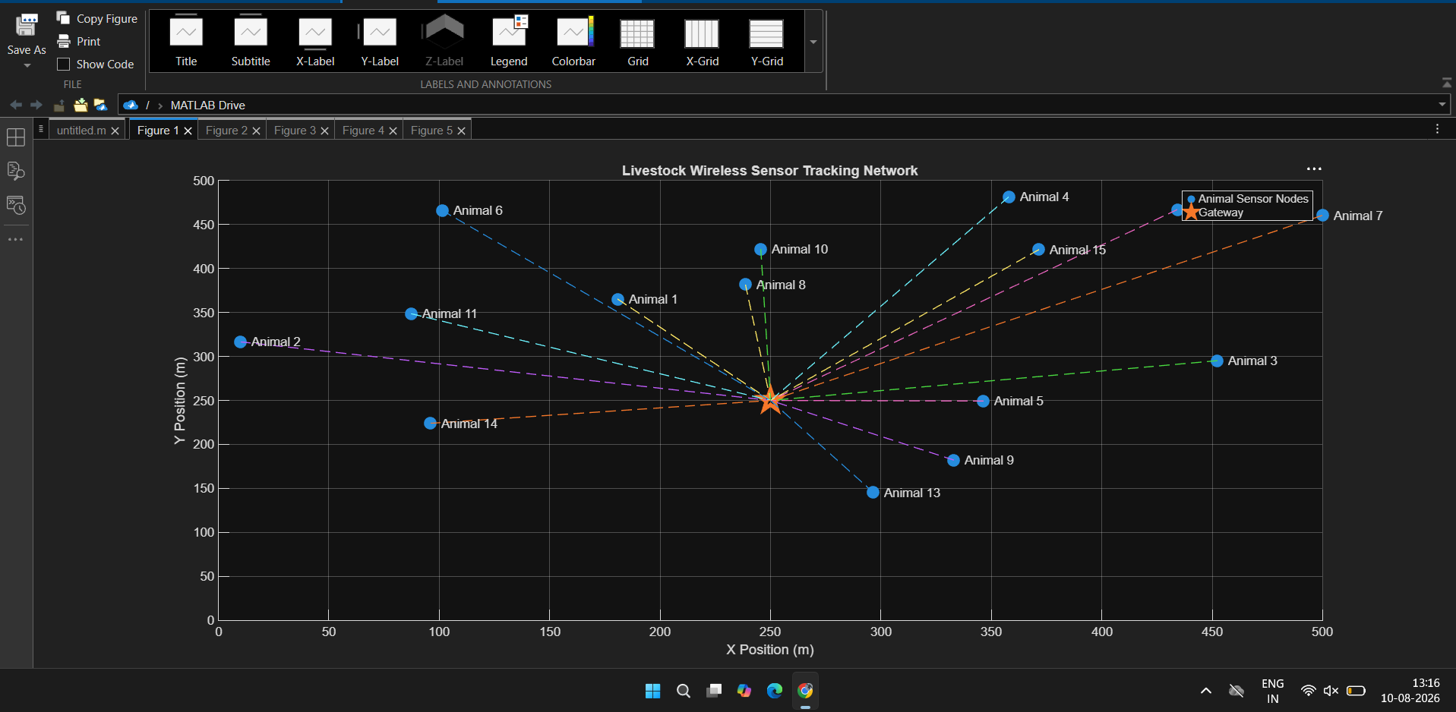
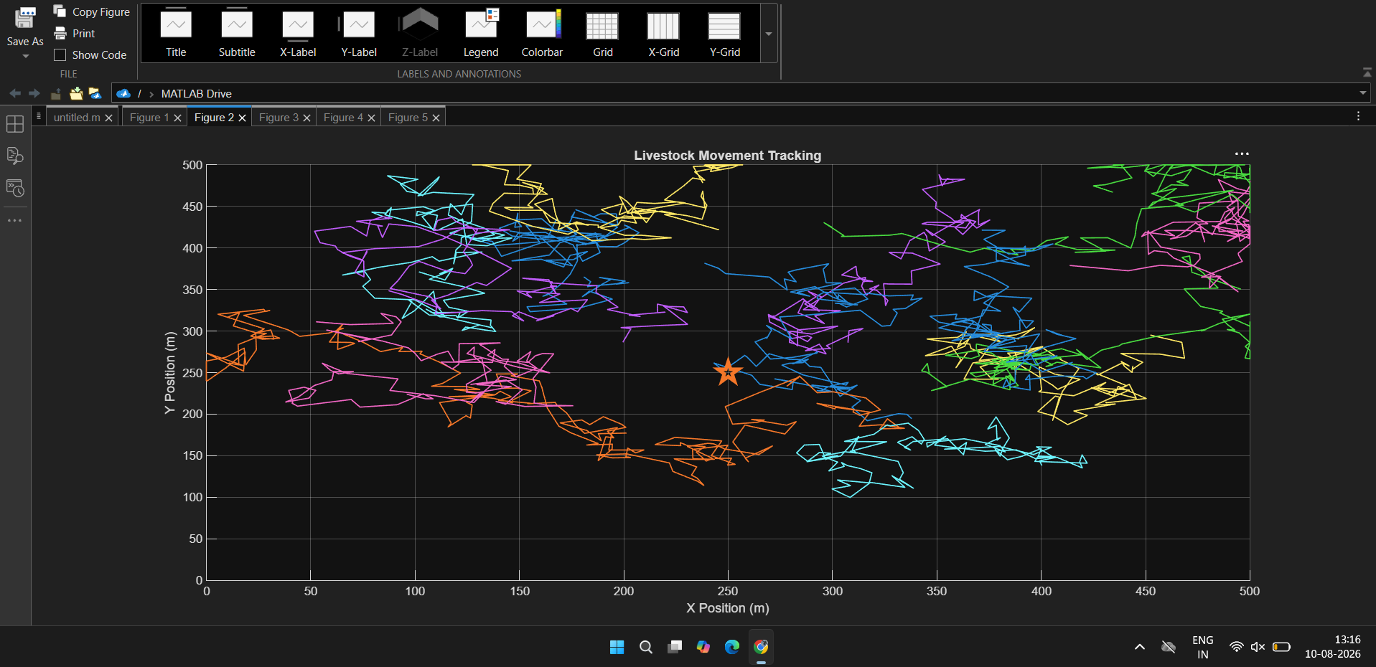

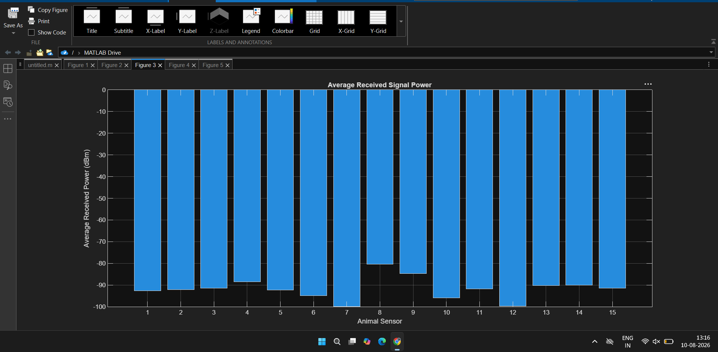
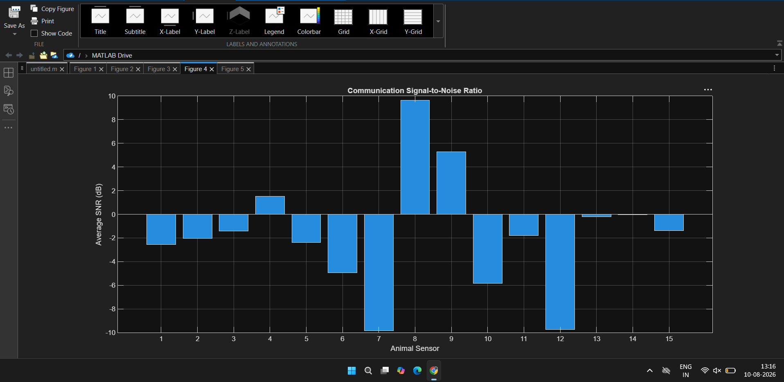
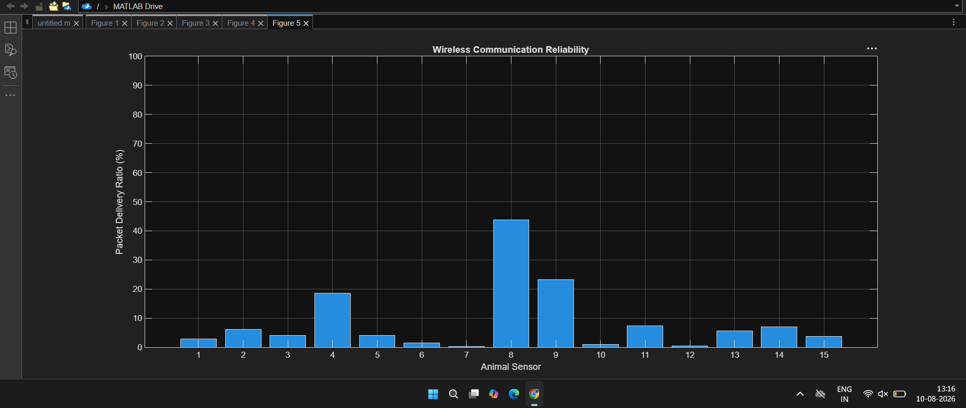
Result: The system successfully tracks livestock wirelessly and maintains reliable communication between animal sensor nodes and the gateway.

